Heavy Weight #7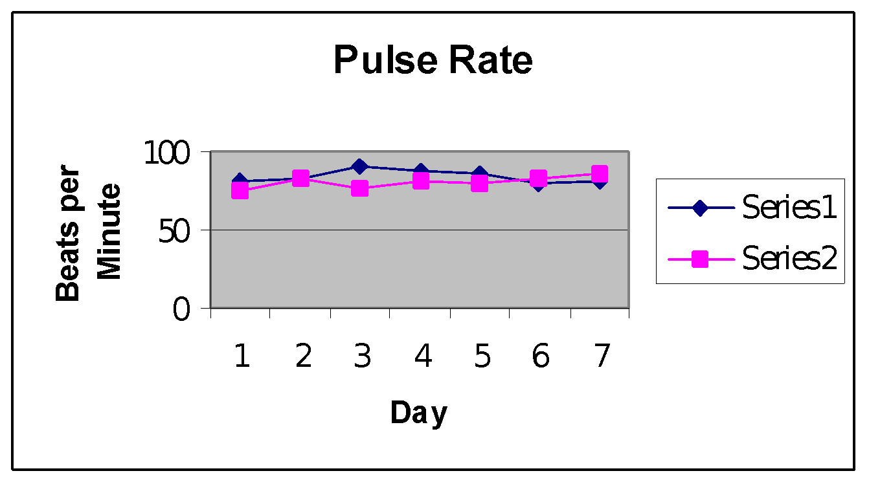

# **Series #1 w/o strip; Series #2 w/ strip**

Series #1 mean: 84.0096 bpm; Series #2 mean: 80.351 bpm

The Series #2 mean has a .00129 probability of occurring by chance when compared to the Series #1 mean. This gives strong evidence that the nasal strip decreased the subject’s pulse rate.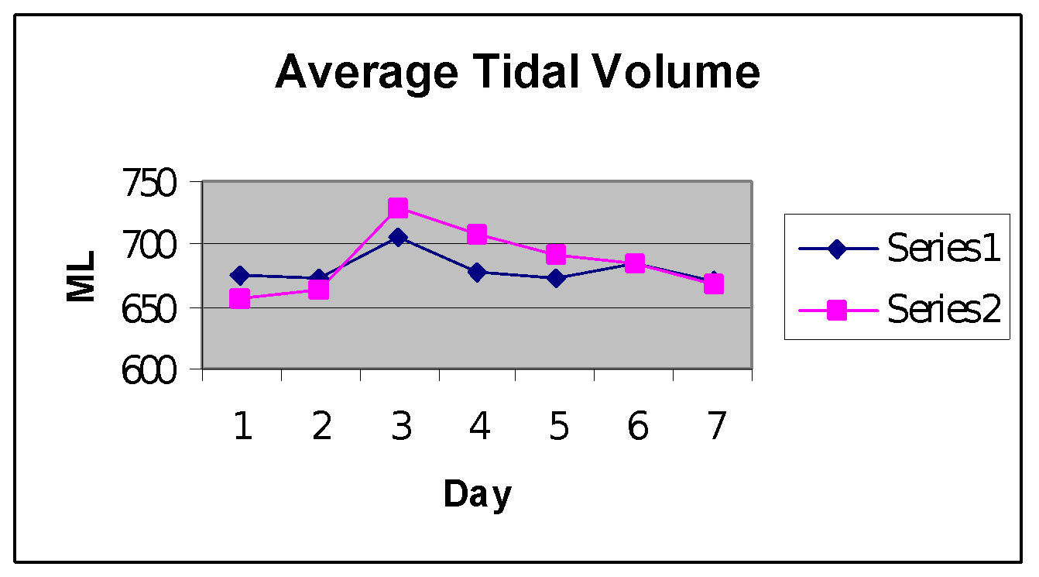

Series #1 mean 679.3324 ml; Series #2 mean: 668.048

The Series #2 mean has a .076 probability of occurring by chance when compared to the Series #1 mean. This gives strong evidence that the nasal strip increased the subject’s tidal volume.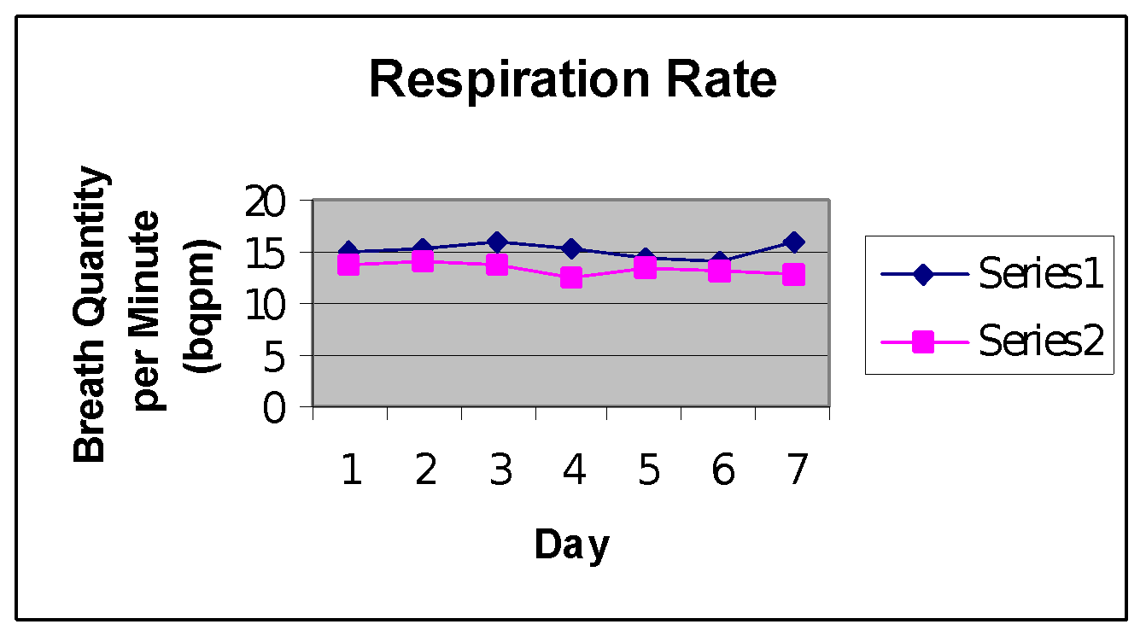

Series #1 mean: 15.1687 bqpm; Series #2 mean: 13.3965 bqpm

The Series #2 mean has less than a .01 probability of occurring by chance when compared to Series #1. This shows strong evidence that he nasal strip decreased the subject’s respiratory rate.

Series #1 mean: 309,137.628 ml; Series #2 mean: 268,485.713 ml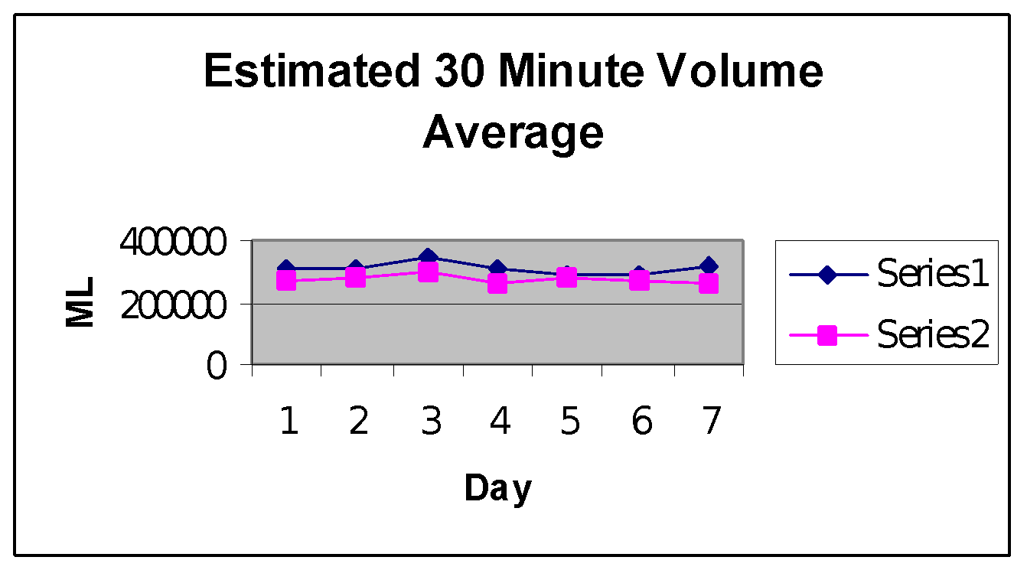

The Series #2 mean has a .1286 probability of occurring by chance. This shows weak evidence that the nasal strip either increased or decreased the subject’s 30 minute volume.